**AI-Powered Imaging Technology for Enhancing Dental Examinations**

|  |
| --- |
| **Daun Kim**  University of Nebraska at Omaha  6001 Dodge St. Omaha, NE 68182 |

**Abstract**

*Fear of visiting the dentist is a common issue, especially among children and elderly patients. The intimidating dental environment, filled with complex equipment, bright lights, and sharp instruments, can discourage individuals from seeking timely dental care. Additionally, conventional dental examinations require healthcare professionals to manually inspect each tooth, which is time-consuming, can cause discomfort, and may lead to missed early signs of decay. Current diagnostic tools such as X-rays, including Orthopantomograms (OPG) and bitewing X-rays, offer effective imaging solutions but come with drawbacks. They require scheduled appointments, can be costly, and may not always be covered by insurance. These limitations highlight the need for an alternative solution that enhances efficiency, improves patient comfort, and reduces diagnostic errors. This project aims to introduce AI-powered imaging technology as a transformative approach to dental examinations. High-resolution images of the oral cavity, captured from multiple angles (occlusal, buccal, and lingual), will be analyzed using machine learning algorithms such as YOLO for object detection. This approach will allow accurate identification of cavities and early signs of decay without invasive procedures or traditional probing methods.*

**Keywords:** AI Imaging Technology, YOLO, Dental Examination, Public Dataset

# Introduction

The traditional dental examination process presents several challenges. Fear and anxiety, particularly among children and elderly patients, discourage dental visits and lead to neglected oral hygiene. Manual inspection of teeth is time-consuming and may result in diagnostic errors or missed cavities. X-rays, while effective, require scheduled appointments, involve radiation exposure, and can be costly if not covered by insurance. Dental hospitals must maintain a large inventory of sterilization equipment, increasing overhead costs and complexity in infection control. A more efficient, accurate, and patient-friendly solution is needed to improve dental examination procedures.

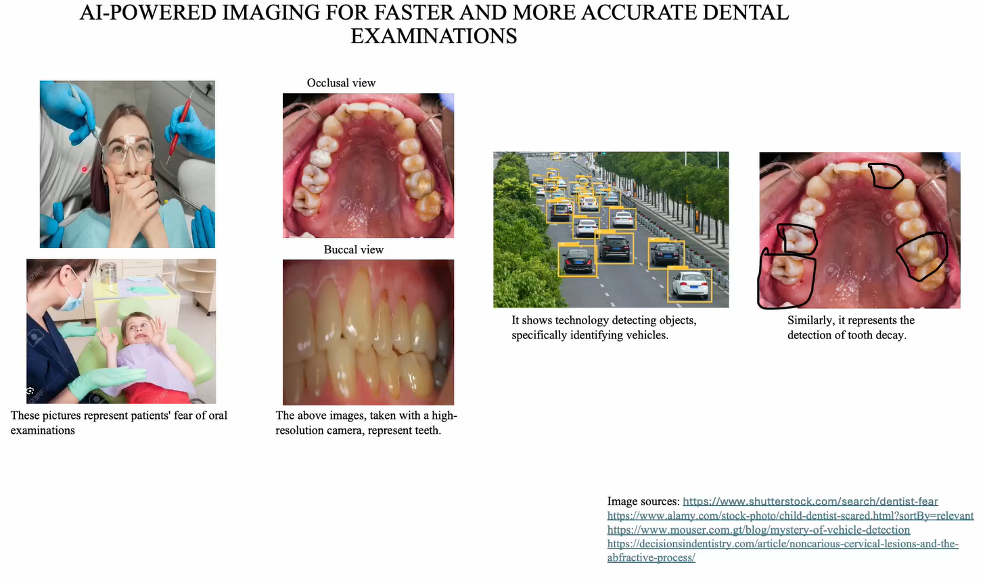

# Literature Review

Recent advancements in AI-driven dental imaging have demonstrated promising results in improving diagnostic accuracy and efficiency. AbuSalim et al. (2024) introduced a multi-granularity approach using YOLO-based object detection models for effective tooth detection and classification. Their findings suggest that AI-powered imaging can significantly enhance diagnostic precision, reducing errors associated with manual inspections. Furthermore, Ramírez-Pedraza et al. (2025) explored deep learning applications in oral hygiene, specifically focusing on automated dental plaque detection using the YOLO framework. Their study highlights the potential of AI models in improving preventive dental care by offering real-time detection and quantification of dental plaque using the O’Leary Index. These advancements indicate a growing trend toward AI integration in dentistry, paving the way for innovative solutions that minimize patient discomfort while optimizing clinical workflows.

This project proposes the development and implementation of an AI-driven imaging system to modernize dental diagnostics. The specific objectives are to improve accuracy by utilizing machine learning-based object detection to enhance early cavity detection and reduce missed diagnoses. It aims to reduce costs by providing a cost-effective alternative to traditional X-rays, minimizing the need for expensive imaging equipment and additional fees. The project seeks to enhance the patient experience by offering a non-invasive, stress-free examination method, especially for patients with dental anxiety. Additionally, it ensures ethical and safe practices by reducing reliance on radiation-based diagnostics and minimizing discomfort through advanced imaging technology. Finally, it simplifies dental clinic operations by decreasing the need for excessive sterilization equipment, making the workflow more efficient and reducing hospital overhead costs.

# Research Question

How can AI-powered imaging technology enhance dental examinations by improving accuracy, reducing patient discomfort, and minimizing reliance on traditional X-ray imaging while maintaining cost-effectiveness and efficiency?

# Project Timeline (3 Months)

|  |  |  |  |
| --- | --- | --- | --- |
| **Task** | **Start Date** | **End Date** | **Duration** |
| Data Collection & Permission Requests | Feb 1, 2024 | Feb 15, 2024 | 2 weeks |
| Data Preprocessing & Annotation | Feb 16, 2024 | Feb 29, 2024 | 2 weeks |
| Model Training & Optimization (YOLOv8) | Mar 1, 2024 | Mar 20, 2024 | 3 weeks |
| Validation & Performance Analysis | Mar 21, 2024 | Apr 5, 2024 | 2 weeks |
| Comparative Analysis with Traditional Methods | Apr 6, 2024 | Apr 15, 2024 | 1.5 weeks |
| Final Report & Presentation Preparation | Apr 16, 2024 | Apr 30, 2024 | 2 weeks |

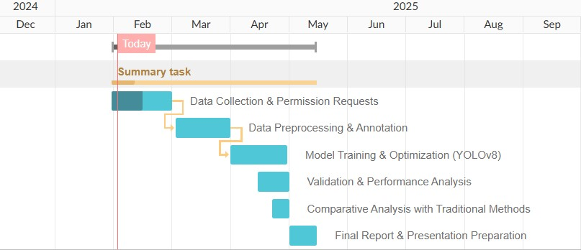

# Technical Plan

This study will build upon previous research but integrate the latest advancements in object detection, specifically utilizing YOLOv8 for multi-granularity tooth analysis and automated dental plaque detection. The research model will follow a data-driven approach, leveraging high-resolution intraoral images to train and validate AI models for tooth classification, cavity detection, and plaque quantification. The methodology will include data collection from diverse dental case studies, preprocessing and augmentation of images, and iterative model training and validation to ensure robustness and accuracy. By employing an updated YOLOv8 framework, the study will refine the detection accuracy beyond prior research models, ensuring enhanced performance in real-time clinical settings. The outcomes of this model will be validated through comparative analysis with traditional dental examination methods, ensuring the feasibility and reliability of AI-assisted diagnostics.

|  |
| --- |
|  |
| **Figure 1. Modified Research Model** |

# Resources Needed

This study will utilize Google Colab as the primary platform for AI model development and analysis, leveraging its cloud computing capabilities for efficient training and testing of YOLOv8 models. The dataset for this research will be sourced from Kaggle’s public dental image datasets, ensuring access to diverse and high-quality data for model training. Additionally, efforts will be made to obtain permission from local dental schools to access real-world clinical data, further enhancing the model's generalizability and performance. The research will follow a structured workflow, beginning with data preprocessing, augmentation, and annotation to prepare high-resolution images for AI analysis. YOLOv8 will then be used for object detection and classification, identifying cavities, plaque, and other dental anomalies with high precision. The model’s performance will be validated using standard evaluation metrics such as precision, recall, and F1-score, ensuring reliability and accuracy. Comparative analysis will be conducted against traditional diagnostic methods to determine the efficacy and practicality of AI-assisted dental examinations.

# Risk Analysis

Several risks could impact the successful completion of this AI-powered dental imaging study. The most significant challenge is limited access to real-world dental imaging data, which could affect model training and validation; this will be mitigated by securing permissions from dental schools and using Kaggle datasets. Technical complexity in YOLOv8 model training presents another risk, requiring continuous debugging and parameter tuning to ensure efficiency. Computational resource limitations, particularly with Google Colab’s memory constraints, may slow progress, which will be addressed by using Colab Pro and optimizing data processing. Time constraints pose another challenge since the project must be completed in three months, necessitating strict adherence to milestones. Team availability and coordination issues may arise due to scheduling conflicts, which will be managed through regular check-ins and clear task delegation. By proactively addressing these risks, the project aims to ensure a successful and timely implementation of AI-powered dental imaging.

# Project Merit

This project will benefit both patients and healthcare providers in multiple ways. For patients, a more comfortable and non-invasive examination process encourages individuals to seek dental care without hesitation. It reduces anxiety associated with dental visits, particularly among children and elderly patients, and enhances early detection of cavities, leading to better preventive care and oral health outcomes. For dental clinics and hospitals, it reduces dependency on costly imaging equipment and sterilization instruments, lowers operational costs by streamlining the diagnostic process, and improves efficiency, allowing dentists to allocate more time for treatment rather than lengthy diagnostic procedures. By leveraging AI and advanced imaging technology, this project aims to transform the dental examination landscape, making it faster, more accurate, and more accessible to all patients.

# References

AbuSalim, S., Zakaria, N., Maqsood, A., Saboor, A., Yew, K. H., Mokhtar, N., & Abdulkadir, S. J. (2024). Multi-granularity tooth analysis via YOLO-based object detection models for effective tooth detection and classification. IAES International Journal of Artificial Intelligence, 13(2), 2081-2092.

Ramírez-Pedraza, A., Salazar-Colores, S., Cardenas-Valle, C., Terven, J., González-Barbosa, J. J., Ornelas-Rodriguez, F. J., ... & Romero-González, J. A. (2025). Deep Learning in Oral Hygiene: Automated Dental Plaque Detection via YOLO Frameworks and Quantification Using the O’Leary Index. Diagnostics, 15(2), 231.